**Name: Manu K Shibu**

**Batcg: Rakhi Nov 2024 2pm**

1.Create a Java program where Animal is the parent class, Mammal extends Animal, and Dog extends Mammal. Implement a method eat() in Animal, walk() in Mammal, and bark() in Dog. Call all methods using a Dog object.

**package** Oops;

**class** Animal {

**public** **void** eat() {

System.***out***.println("Animals Eating:");

}

}

**class** Mammals **extends** Animal {

**public** **void** walk() {

System.***out***.println("Mammals walking");

}

}

**class** Dogg **extends** Mammals {

**public** **void** bark() {

System.***out***.println("Dog barking:");

}

}

**public** **class** Method_Overiding {

**public** **static** **void** main(String[] args) {

Dogg d = **new** Dogg();

d.bark();

d.eat();

d.walk();

}

}

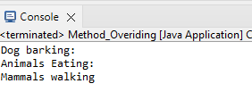

2.write a program to reverse a string

**package** assigments;

**class** Personal {

**public** **static** **void** main(String[] args) {

String m1 = "manu";

String reversedstring = "";

**for** (**int** i = m1.length() - 1; i >= 0; i--) {

reversedstring = reversedstring + m1.charAt(i);

}

System.***out***.println("String before reverse: " + m1);

System.***out***.println("Reversed string: " + reversedstring);

}

}

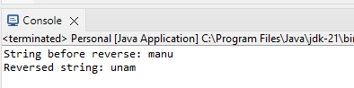  
  
3.create a class Student.It contains two methods mark and show details.class teacher with department method have to extend student class and implement interface principal with resign and rejoin methods.

**package** Oops;

**interface** principal {

**void** Resign();

**void** Rejoin();

}

**class** Student {

**public** **void** mark() {

System.***out***.println("marks of student:");

}

**public** **void** showdetails() {

System.***out***.println("show the details of student:");

}

}

**class** Teacher **extends** Student **implements** principal {

**public** **void** department() {

}

@Override

**public** **void** Resign() {

System.***out***.println("Resignation from the course:");

}

@Override

**public** **void** Rejoin() {

System.***out***.println("Rejoin the course:");

}

}

**public** **class** Interface {

**public** **static** **void** main(String[] args) {

Teacher t = **new** Teacher();

t.department();

t.mark();

t.showdetails();

t.Resign();

t.Rejoin();

}

}

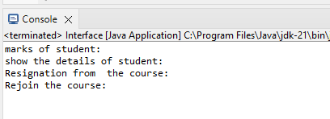  
  
4.write a program to find the largest number in an array

**package** assigments;

**import** java.util.Scanner;

**public** **class** Personal {

**public** **static** **void** main(String[] args) {

**int**[] a = **new** **int**[5];

Scanner sc = **new** Scanner(System.***in***);

System.***out***.println("Enter the elements in the array:");

**for** (**int** i = 0; i < a.length; i++) {

a[i] = sc.nextInt();

}

System.***out***.println("Array elements:");

**for** (**int** v : a) {

System.***out***.print(v + " ");

}

**int** largest = a[0];

**for** (**int** i = 1; i < a.length; i++) {

**if** (a[i] > largest) {

largest = a[i];

}

}

System.***out***.println("\nThe largest element in the array is: " + largest);

sc.close();

}

}

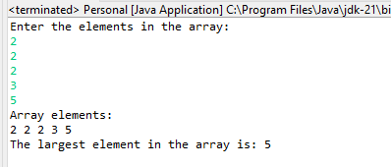

5.write a program to swap two numbers without using third variable

**package** assigments;

**public** **class** Personal {

**public** **static** **void** main(String[] args) {

**int** a = 10;

**int** b = 20;

System.***out***.println("Before swap:" + a + " " + b);

a = a + b;

b = a - b;

a = a - b;

System.***out***.println("After swap: " + a + " " + b);

}

}

